Balisacan, Mark Justin F. BSIT 4-1 WMAD
Binuya, John Lloyd A.
Reyes, Allysa B.

WEEK 3: SYSTEM DEVELOPMENT I

I. INTENDED LEARNING OUTCOME (ILO)
At the end of this laboratory activity, students should be able to:
Develop and implement the core functionalities, user interfaces, and system workflows specified in the approved project requirements while applying established coding standards and collaborative development practices.

II. PERFORMANCE TASK
Following the successful completion of the development environment setup and database implementation during Week 2, your team shall begin actual system development.
You are required to implement the project's priority features, develop user interface components, and establish system workflows that demonstrate the project's core functionality.
The outputs produced this week will serve as evidence that the project has transitioned from planning to actual software development.

III. WEEK 3 ACTIVITIES
Activity 1 – Module Development Planning
Activity 2 – Core Functionality Development
Activity 3 – User Interface Development
Activity 4 – Workflow Configuration
Activity 5 – Internal Functionality Verification
Activity 6 – Repository Update and Version Control
Activity 7 – Progress Reporting and Adviser Consultation

ACTIVITY 1
MODULE DEVELOPMENT PLANNING
Purpose
To identify and prioritize the modules that will be developed during Week 3.
Procedure
- Review the approved requirements specification.
- Review the Work Breakdown Structure (WBS).
- Identify priority modules for development.
- Assign responsibilities among team members.
- Complete Form 1.

FORM 1
WEEK 3 MODULE DEVELOPMENT PLAN

Directions
List all modules scheduled for development this week.
Module | Description | Assigned Member | Target Completion
User Authentication | User registration and login with Email OTP verification and role-based access (Admin, Lineman, Resident). | Mark Justin Balisacan  John Lloyd Binuya | August 6, 2026
Lineman Module | Allow lineman to determine the path toward the report location through the map. | John Lloyd Binuya | August 6, 2026
Resident Module | Resident can view the location of the lineman when the status of the report is “on progress”. | John Lloyd Binuya | August 6, 2026
Report Receiving schedule | Previously, reports received during working hours were manually forwarded by the main office to the appropriate branch, while reports received outside working hours were handled by the main office. In the proposed system, reports submitted during working hours are automatically routed to the appropriate branch, eliminating the need for manual forwarding. | Mark Justin Balisacan  John Lloyd Binuya | August 6, 2026
Notification System | When the admin set a schedule for the power outage, those residents who have their address listed on the affected barangay, they will receive a notification informing them that they are affected on the power outage. | Mark Justin Balisacan  John Lloyd Binuya | August 6, 2026
Admin Dashboard | Enables administrators to view, validate, assign and monitor reports through an interactive dashboard. | Mark Justin Balisacan | August 6, 2026
Incident Module | This module displays active incidents in a table showing status, priority, customer, description, location details, assigned linemen, and time, allowing admins to assign lineman and view details. | Mark Justin Balisacan | August 6, 2026

Priority Classification
☑ High Priority
□ Medium Priority
□ Low Priority

Team Approval
Member Signatures:

ACTIVITY 2
CORE FUNCTIONALITY DEVELOPMENT

Purpose
To develop the major business processes and functions required by the project.
Examples
Depending on project type:
- User Registration
- User Authentication
- Records Management
- Inventory Processing
- Appointment Scheduling
- Reporting Module
- Data Analytics Module
- Security Module
Procedure
- Develop assigned functionality.
- Apply approved coding standards.
- Test functionality locally.
- Commit source code to repository.
- Complete Form 2.
FORM 2
CORE FUNCTIONALITY DEVELOPMENT REPORT

Directions
Document each completed functionality.
Functionality | Description | Status
Application Language (Filipino and English) | The Resident and Lineman Users can change the Laguage into Tagalog or English | In Progress
Lineman Resident Descriptive analytics and report list filtering | We display the count of report through the report status (Pending, In Progress, Resolved, Rejected) and when clicked it will filter the report depending on the statuses. | Complete
Edit Report | When the status of the report is “Pending” the resident can still edit the report. | Complete
Accept/Reject Report | This functionality allows administrators to validate and prioritize incoming crowdsourced incident reports submitted by residents. | In Progress
Assign Lineman | This functionality enables the administrator to select and dispatch available field personnel to specific incident locations based on urgency and geographic proximity. | In Progress
See Details of the Report | This functionality lets admin view comprehensive information about a specific incident. | In Progress

Functionality Verification
Test Conducted | Result
Input Validation | Pass
Process Execution | Pass
Output Generation | Pass

Evidence Attached
MOBILE
□ Screenshot of Functionality

Application Language (Filipino and English)
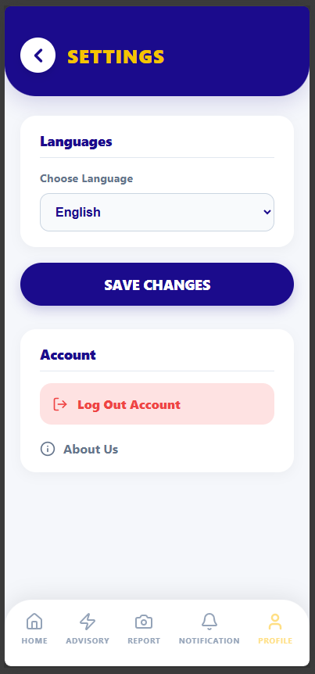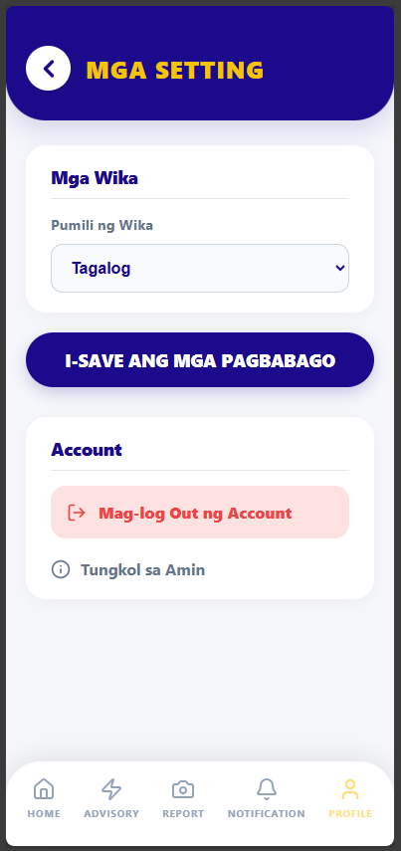

Lineman Resident Descriptive analytics and report list filtering
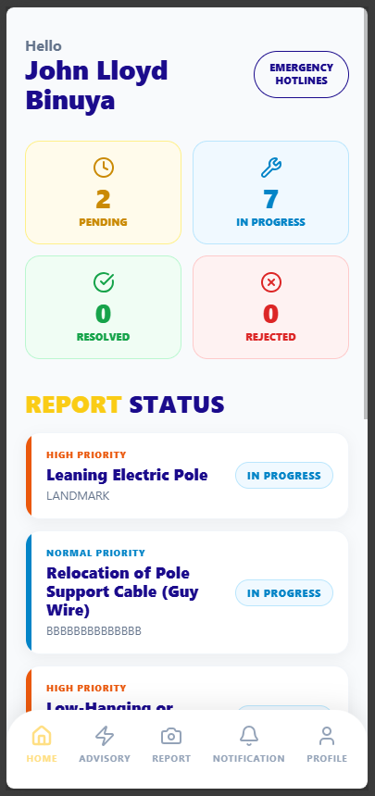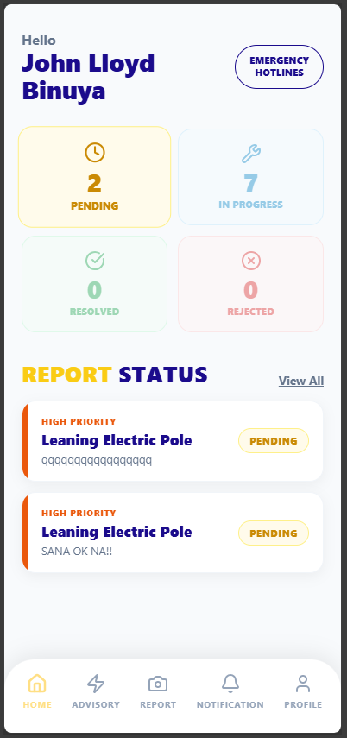

Edit Report
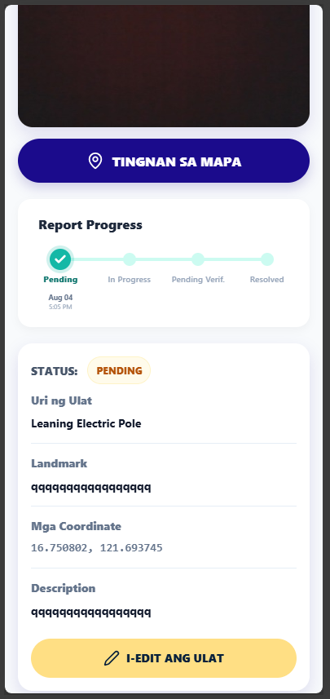
□ Source Code Screenshot
Application Language (Filipino and English)
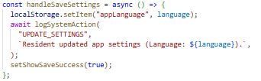
Lineman Resident Descriptive Edit Report
analytics and report list filtering
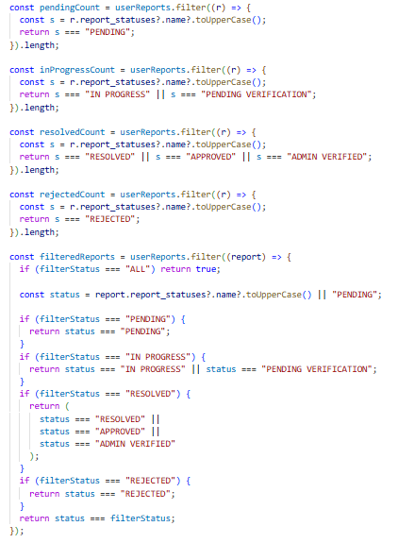
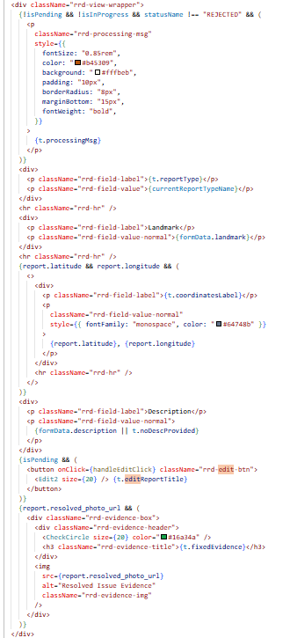

□ Demonstration Screenshot

Application Language (Filipino and English)
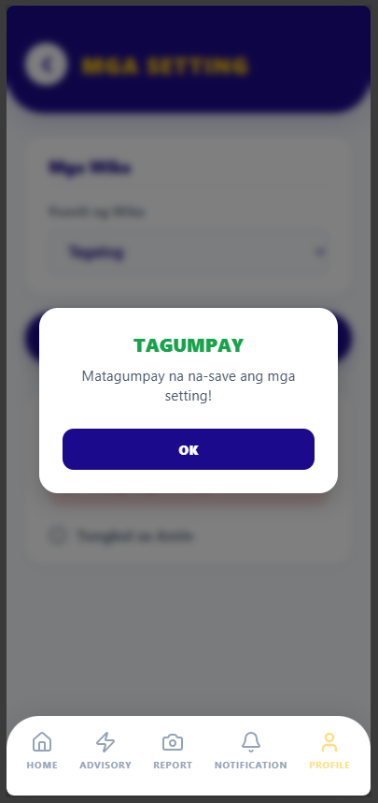

Lineman Resident Descriptive analytics and report list filtering

Edit Report
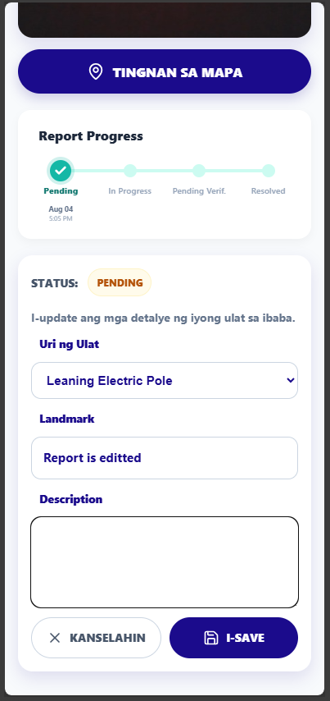

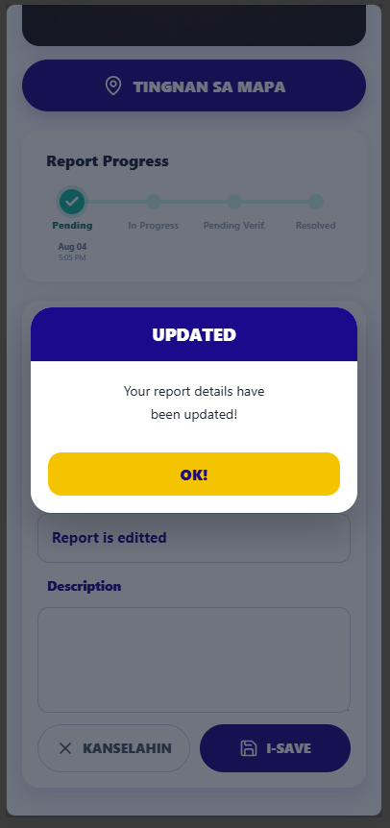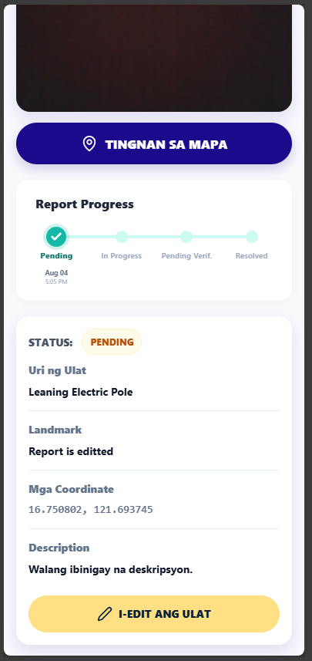
WEB
□ Screenshot of Functionality

Accept/Reject Report
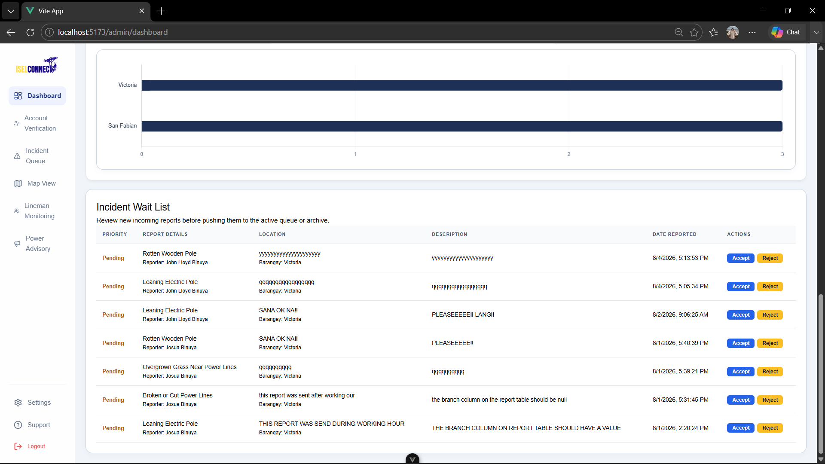
Assign Lineman
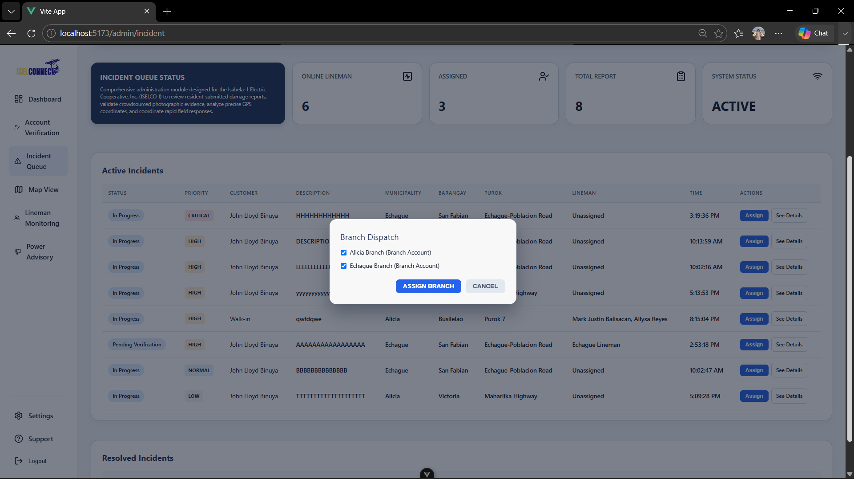
See Details of the Report
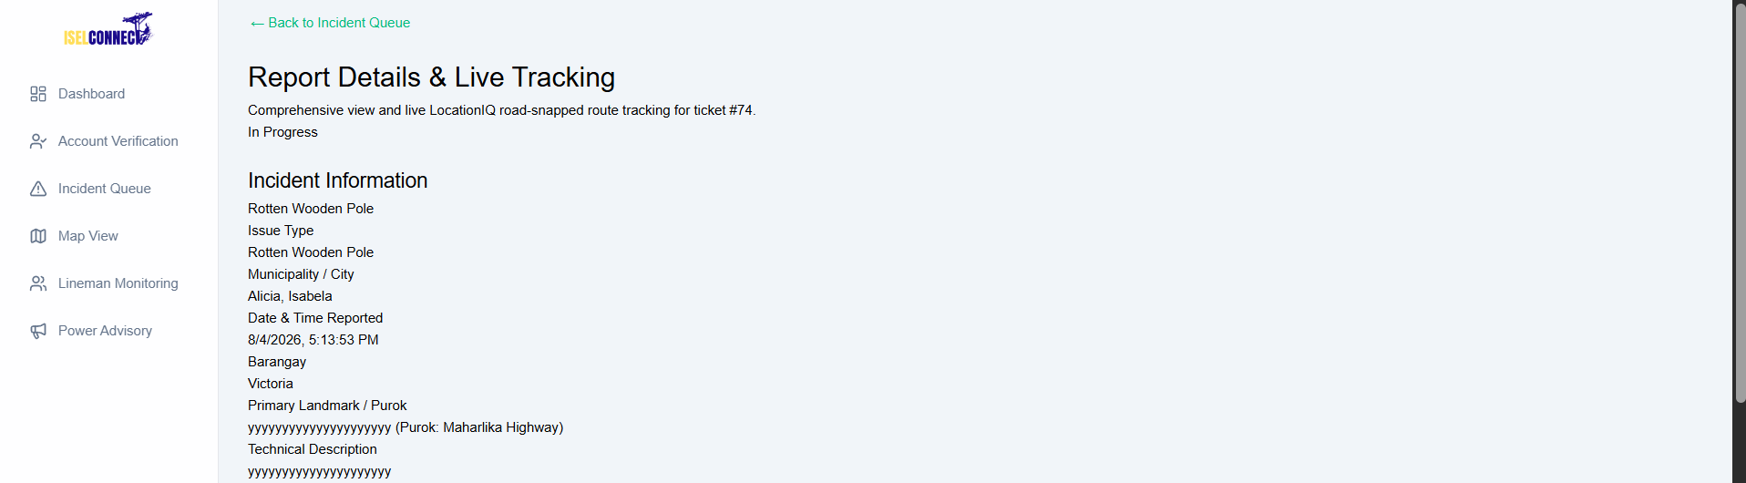

□ Source Code Screenshot
Accept/Reject Report
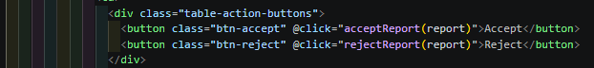
Assign Lineman
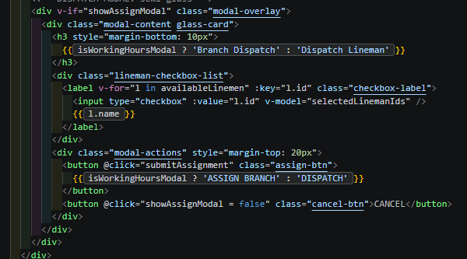

See Details of the Report
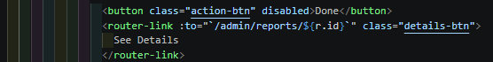

□ Demonstration Screenshot
Accept/Reject Report
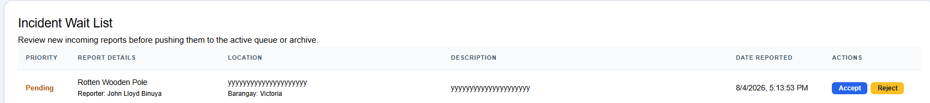

Assign Lineman

See Details of the Report

ACTIVITY 3
USER INTERFACE DEVELOPMENT

Purpose
To implement user-friendly interfaces aligned with approved system designs.
Procedure
- Develop system screens.
- Implement navigation menus.
- Apply usability principles.
- Verify screen responsiveness.
- Complete Form 3.

FORM 3
USER INTERFACE DEVELOPMENT REPORT

Directions
List all developed interfaces.
Interface/Page | Purpose | Status
Login Page | Provides secure user authentication and grants access to the system based on user credentials and roles. | Complete
Dashboard | Displays an overview of relevant information, system activities, notifications, and key data according to the user's role. | In Progress
User Management | Allows authorized users to manage user accounts, profiles, roles, and permissions within the system. | Complete
Reports Page |  | Complete
  Enables users to create, view, update, monitor, and manage reports, including their status and related details.

User Interface Checklist
Item | Completed
Consistent Design | ☑
Functional Navigation | ☑
Responsive Layout | ☒
Error Messages Implemented | ☒

Required Evidence
MOBILE
□ Interface Screenshots
Residents  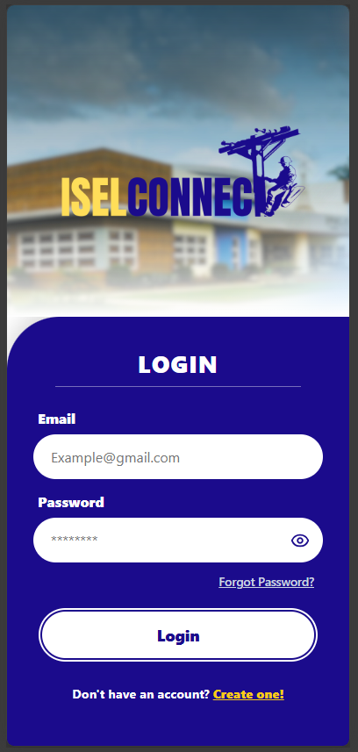  Login Page  User Management  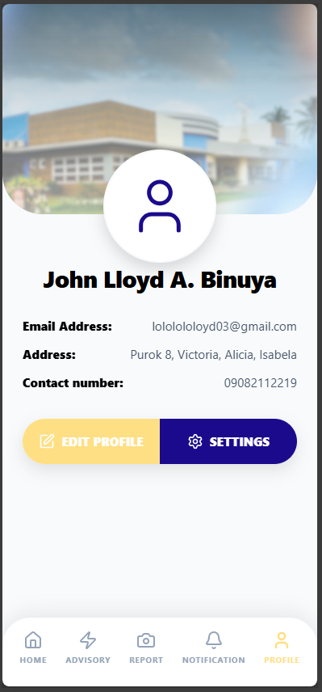  Lineman  Login Page | Dashboard  Report Page  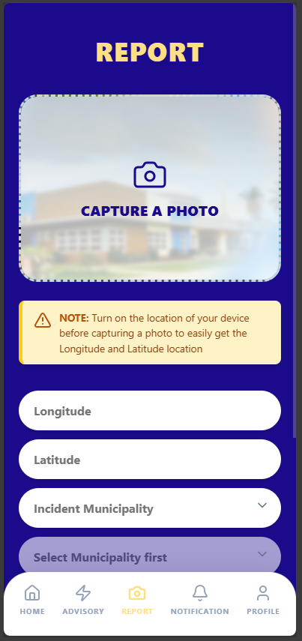  Dashboard and Report Page  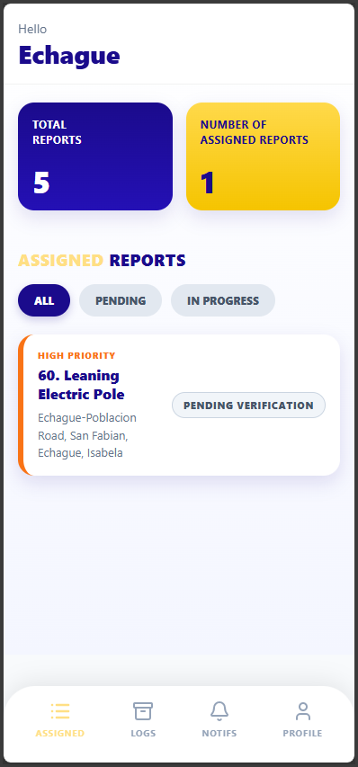
User Management  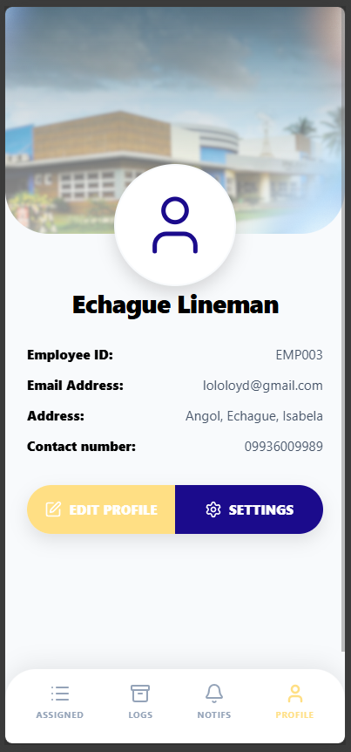 | □ Mobile/Responsive View Screenshot (if applicable)  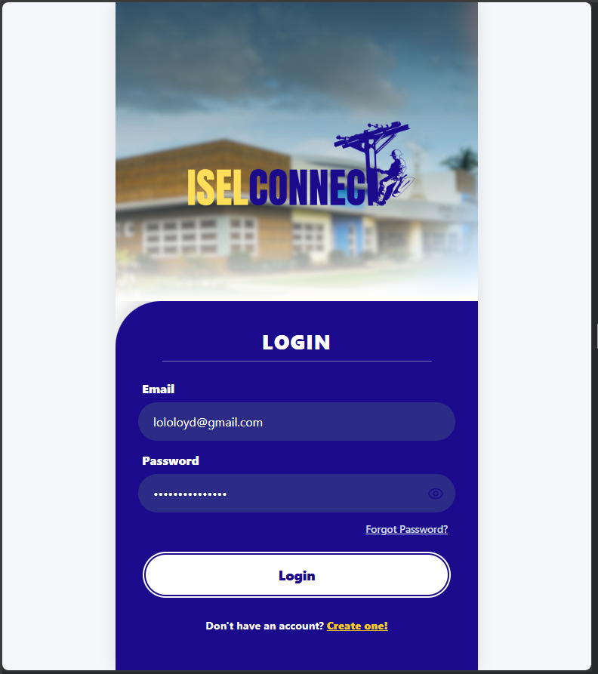

WEB
□ Interface Screenshots  Login Page  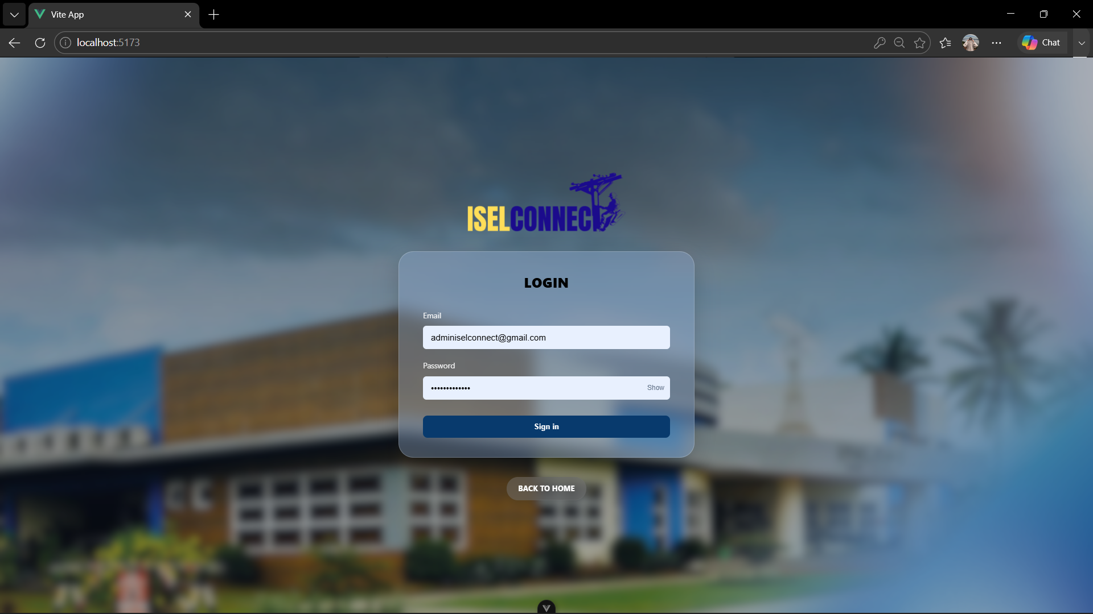  User Management  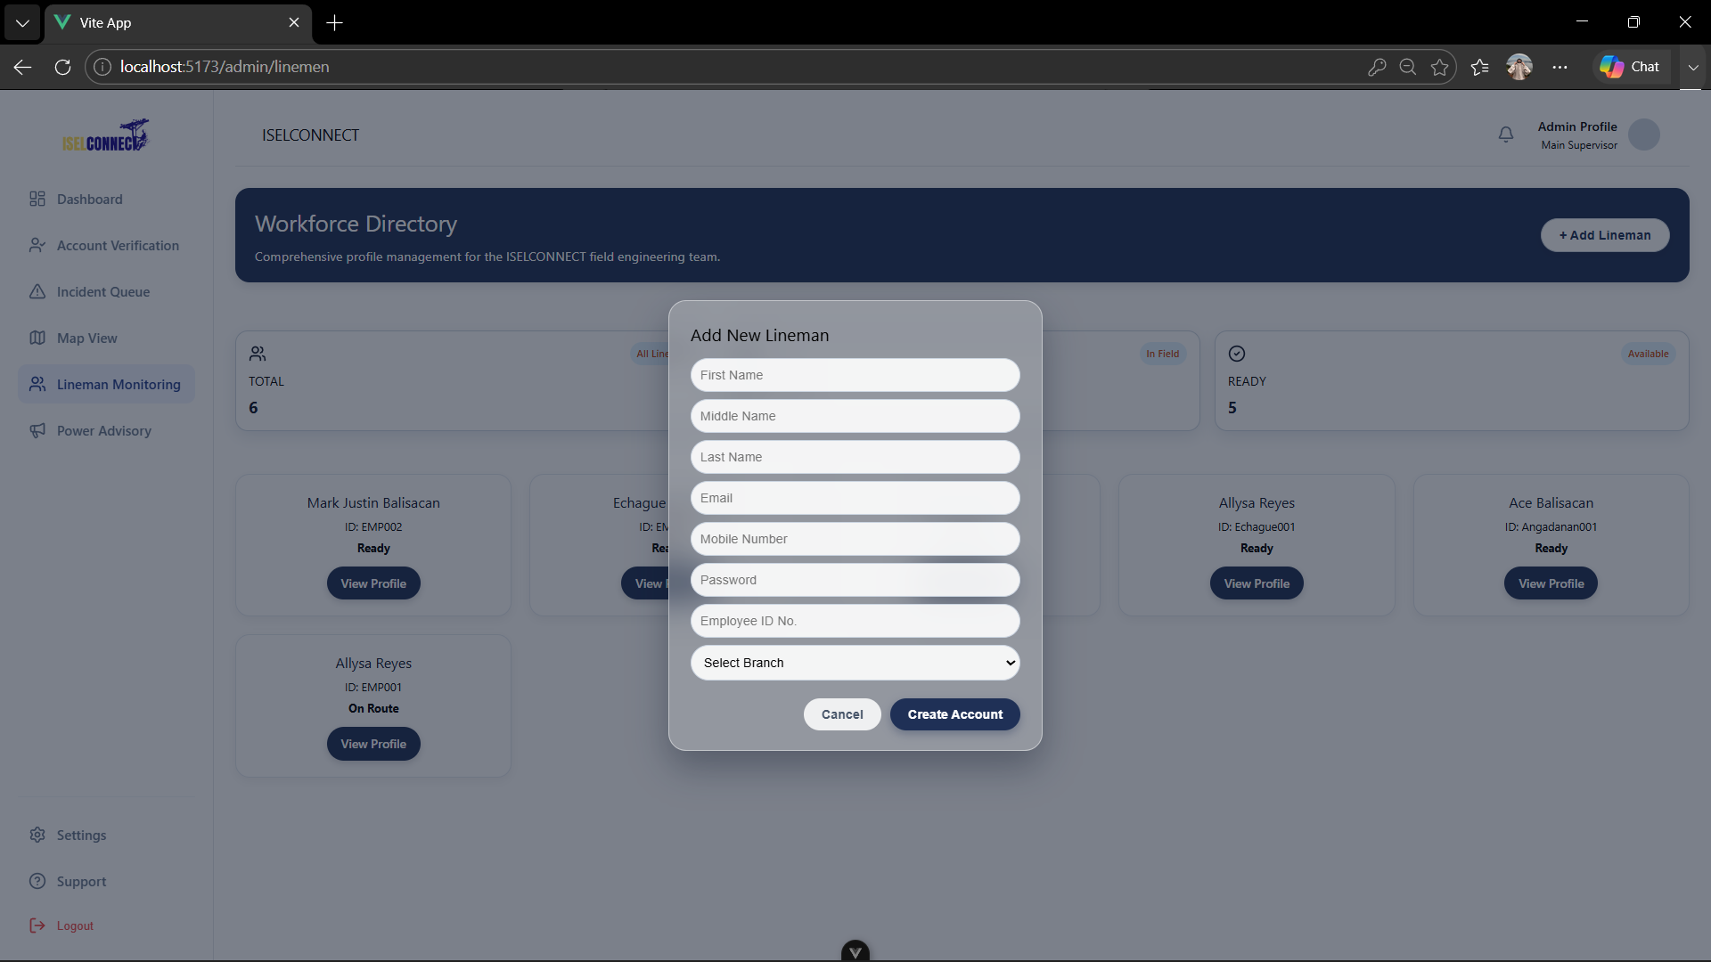 | Dashboard  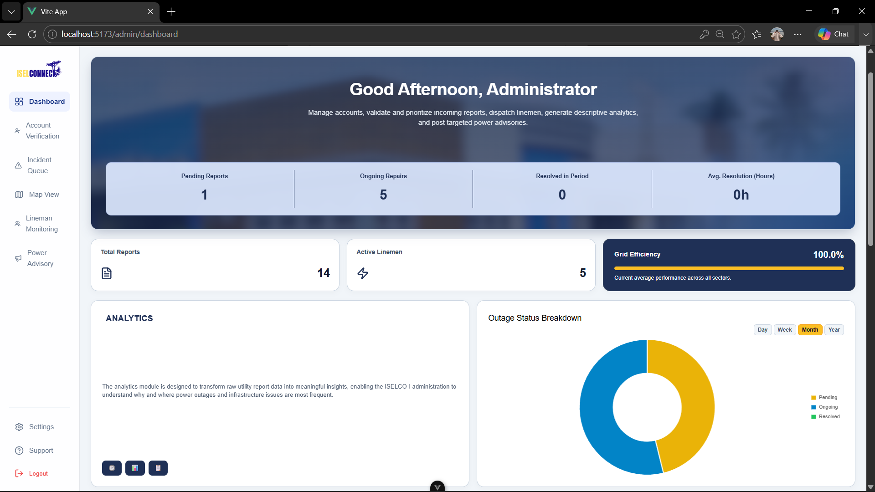  Reports Page  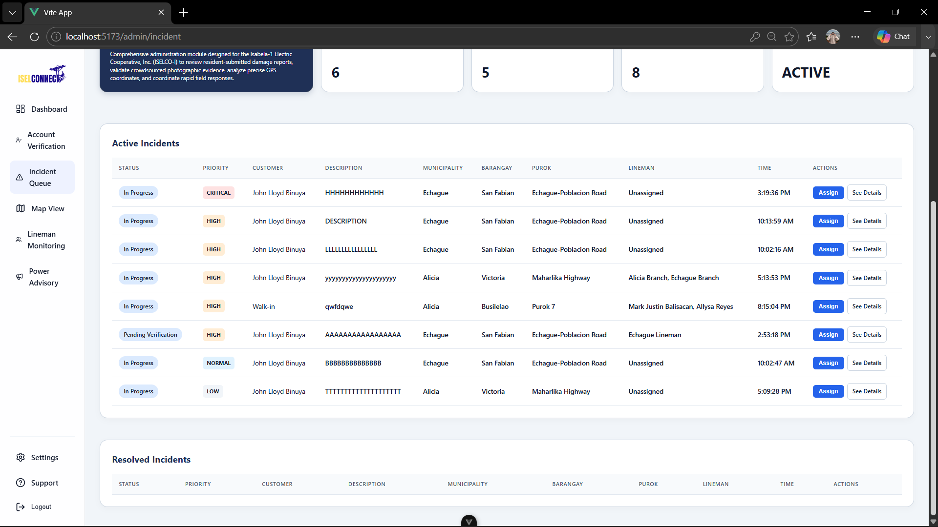
□ Navigation Demonstration  Login Page  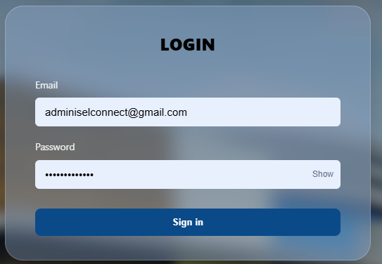  User Management | Dashboard Reports Page
ACTIVITY 4
SYSTEM WORKFLOW CONFIGURATION

Purpose
To establish the logical flow of system processes.
Procedure
- Identify major transactions.
- Configure workflow sequences.
- Test process flow.
- Verify system responses.
- Complete Form 4.

FORM 4
SYSTEM WORKFLOW VALIDATION FORM

Directions
Document workflow implementation.
Workflow | Status | Remarks
Login Process | Implemented | Functional and completed.
Data Entry Process | Implemented | Functional, enhancements are ongoing.
Data Processing | Implemented | Functional, enhancements are ongoing.
Report Generation | Implemented | Functional, enhancements are ongoing.

Workflow Verification
Validation Item | Result
Inputs Accepted Correctly | Pass
Process Executes Correctly | Pass
Output Generated Correctly | Pass

Evidence Attached
□ Workflow Diagram
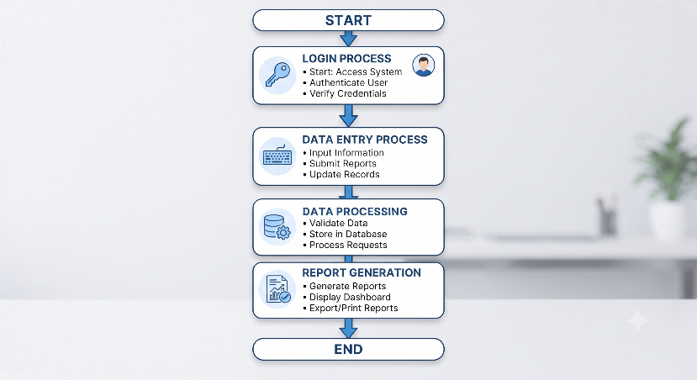
□ Workflow Demonstration Screenshots

MOBILE
Sign up Process

Access the application
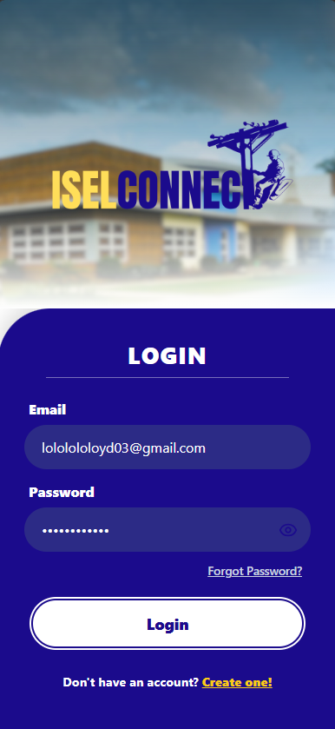

Authenticate the user
- Sign up
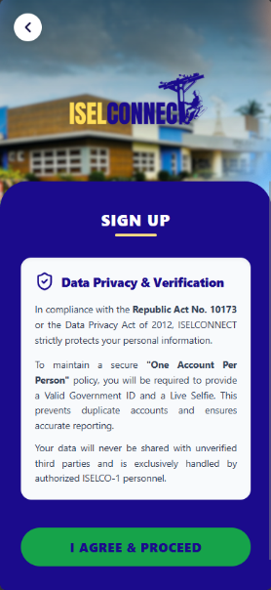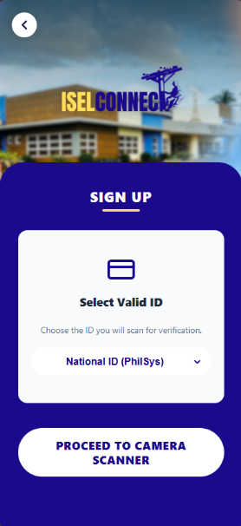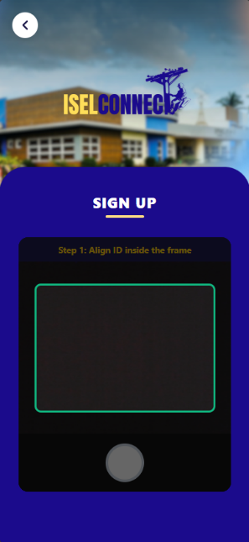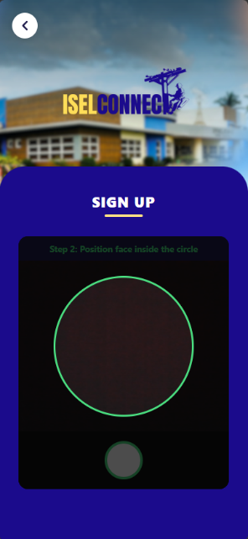

Filling up the information

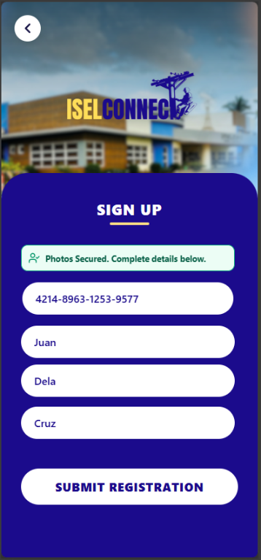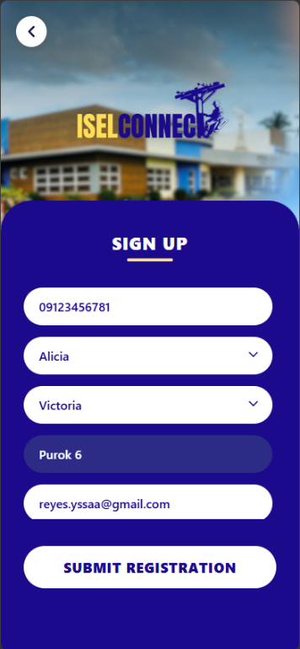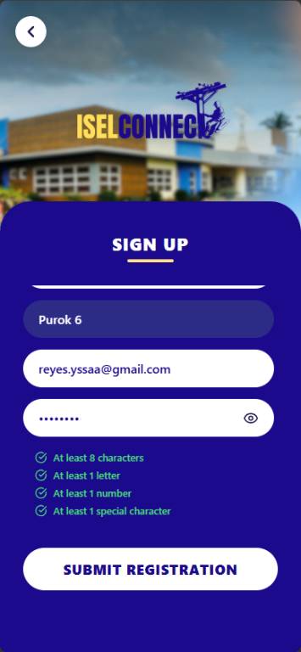
Email OTP
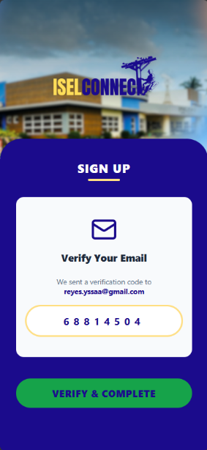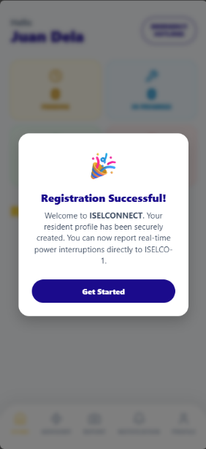

Login Process
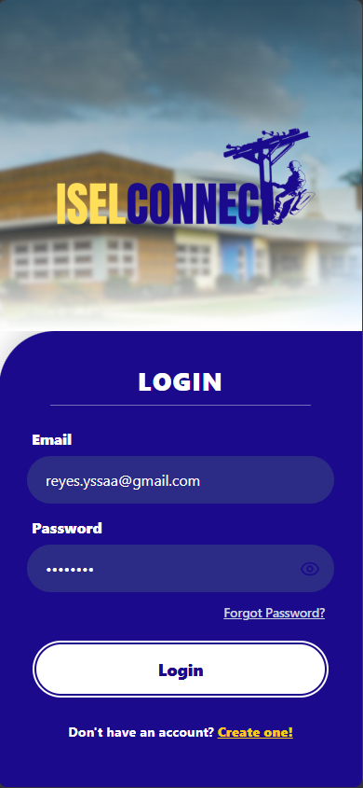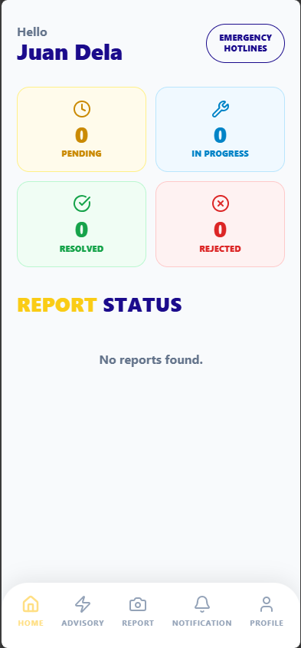

Data Entry Process
Reporting
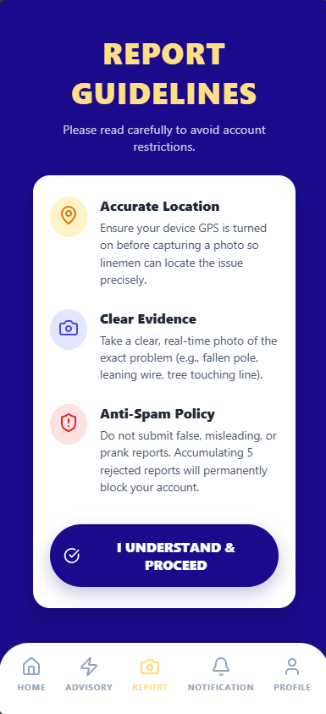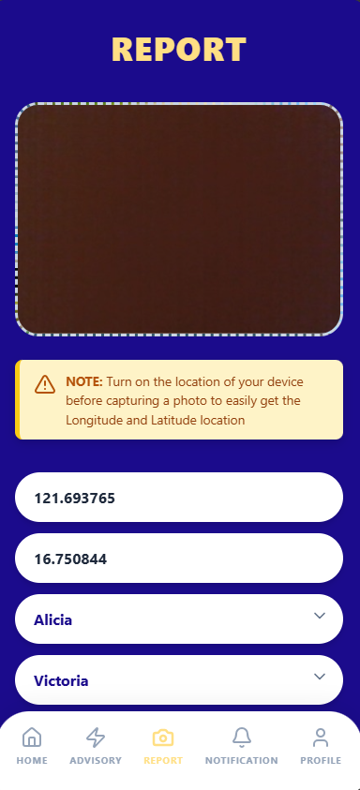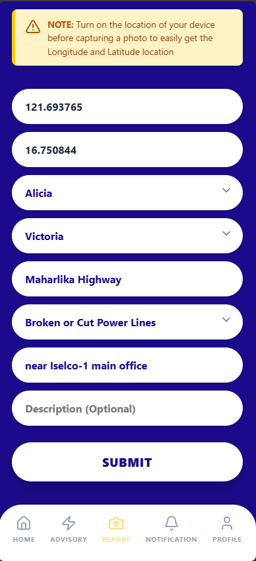
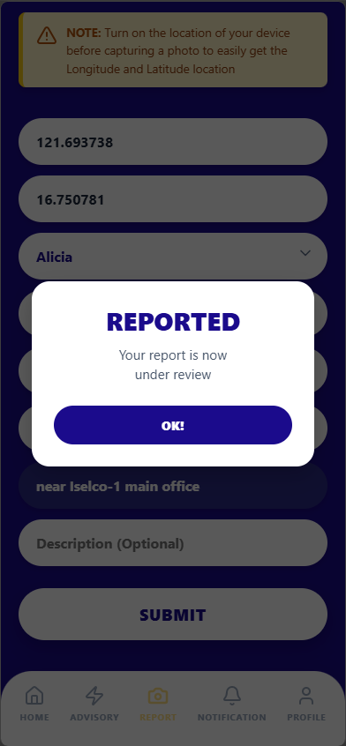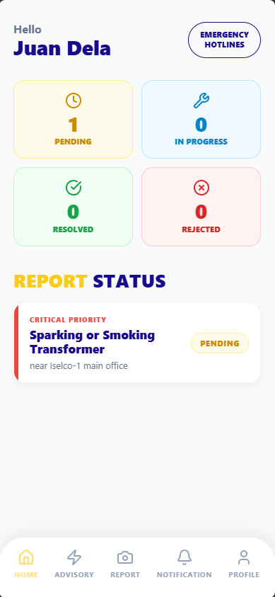

Database
Editing the Report (edit the description from “near iselco-1” to “in front of iselco-1”
Editing the Report (edit the description from “near iselco-1” to “in front of iselco-1”
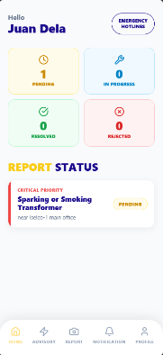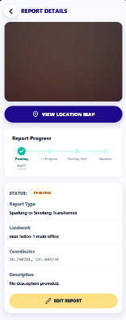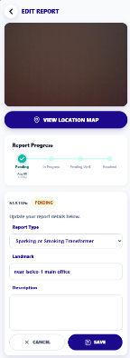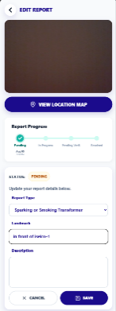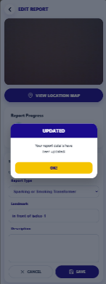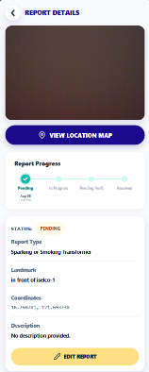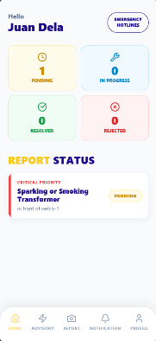

Store in database

WEB
Login Process

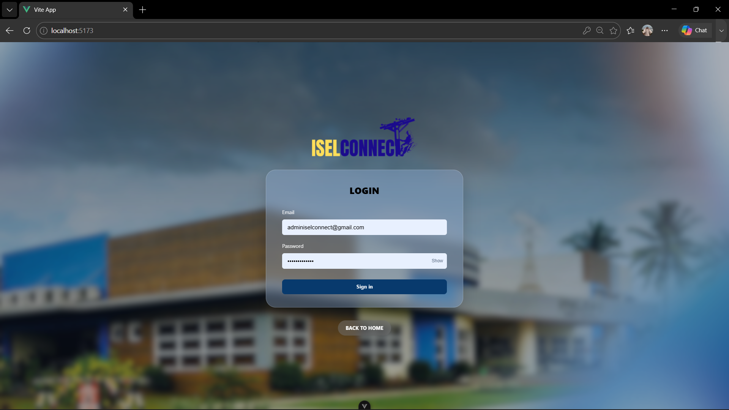

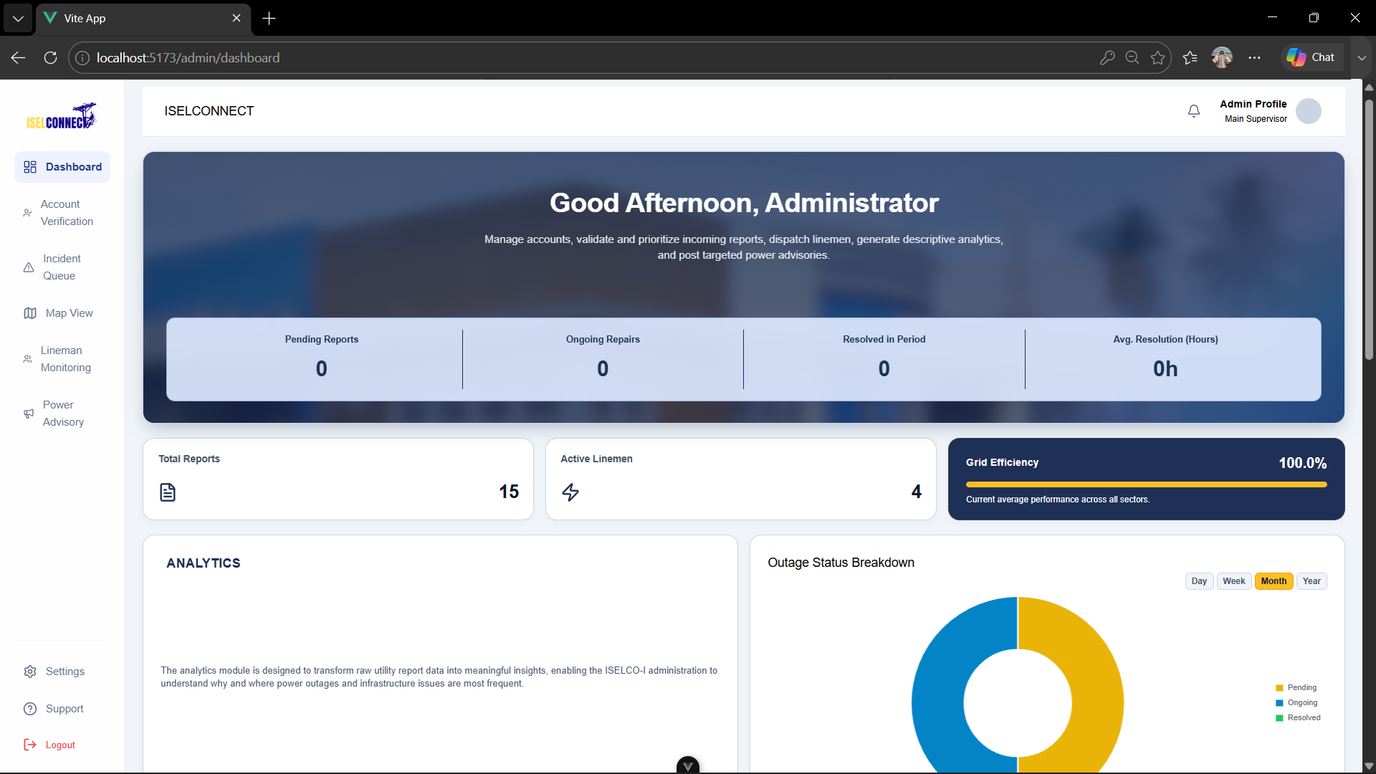

Data Entry Process
Manual Reporting
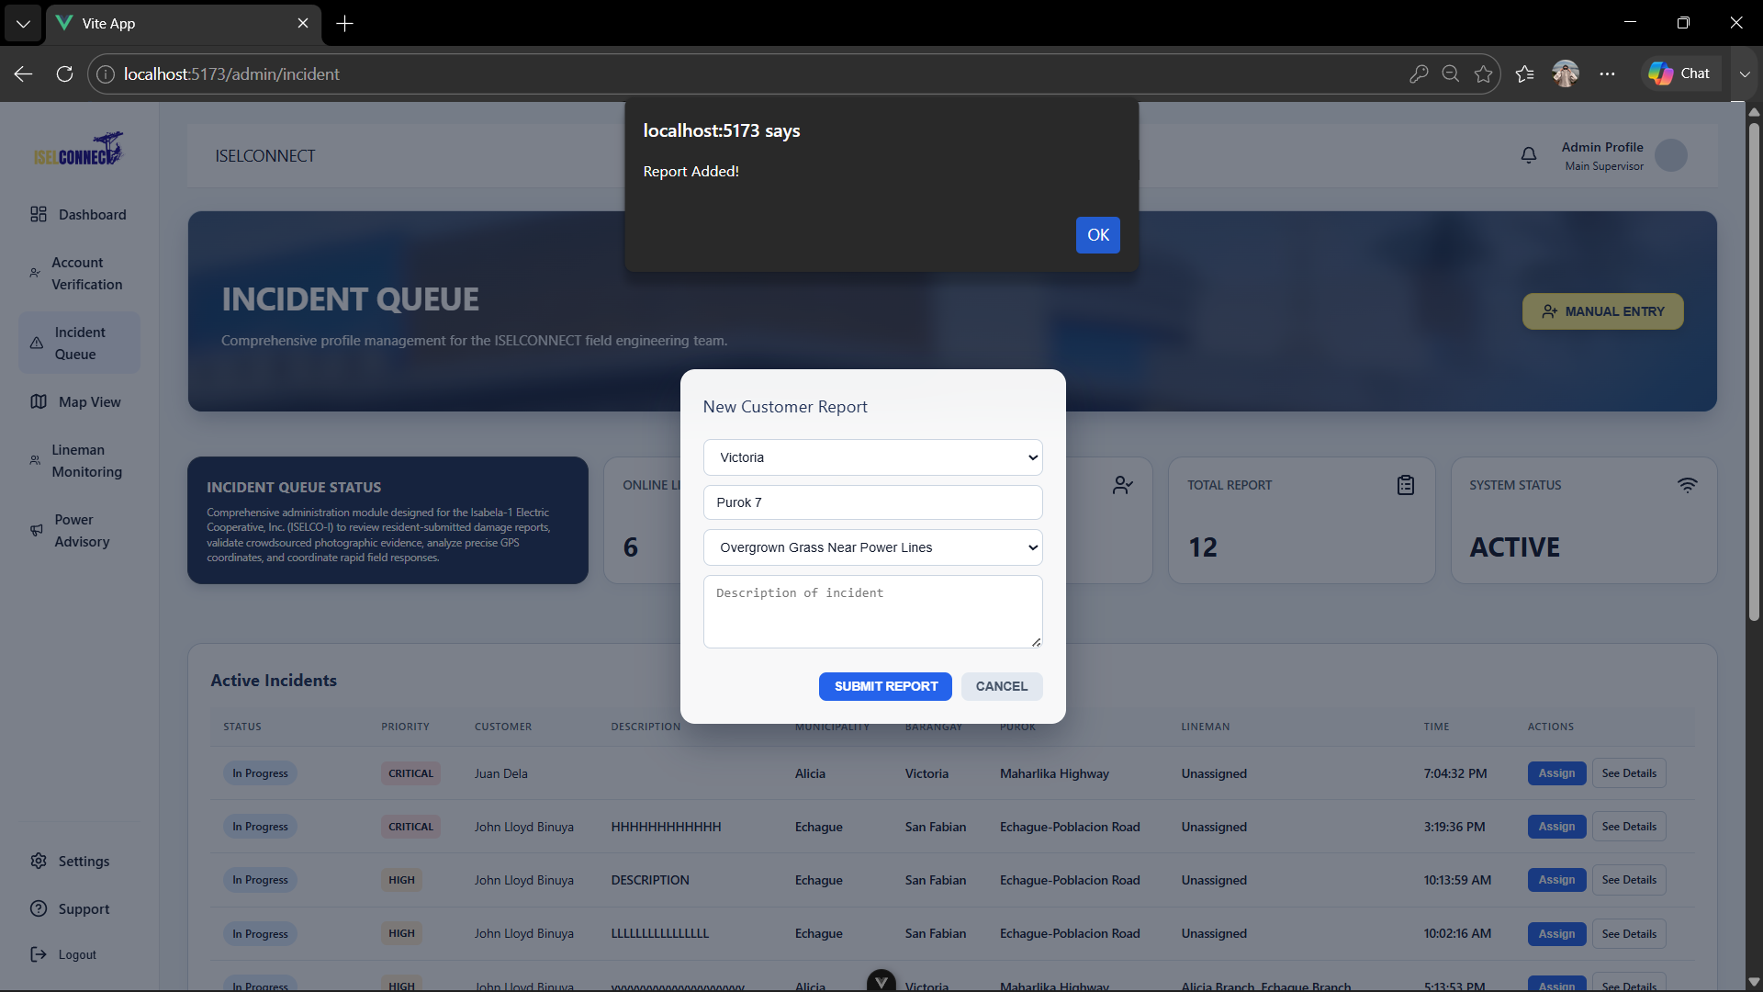
Database

Accept Report
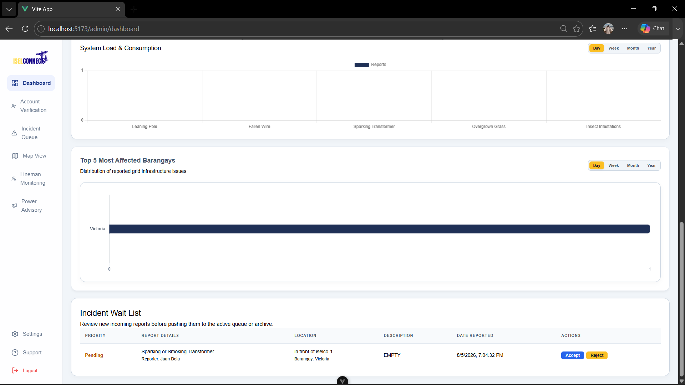
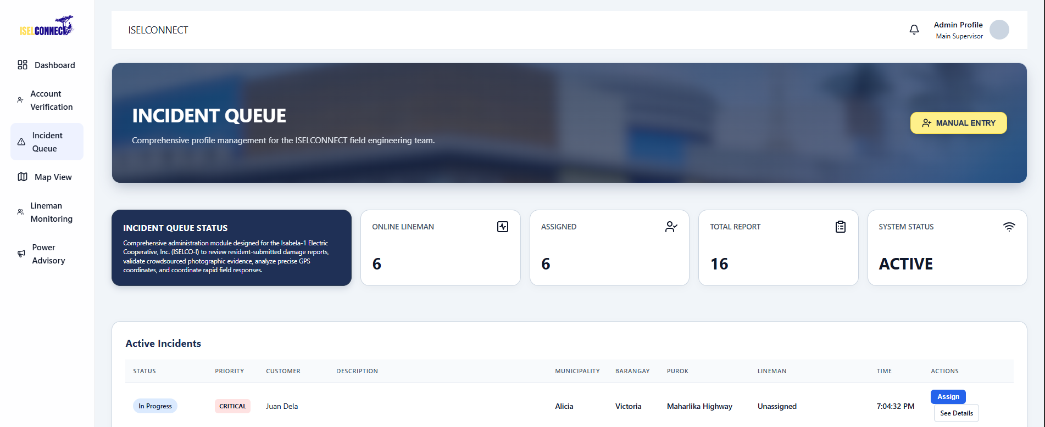
Database
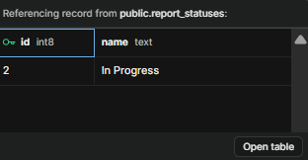
Reject Report

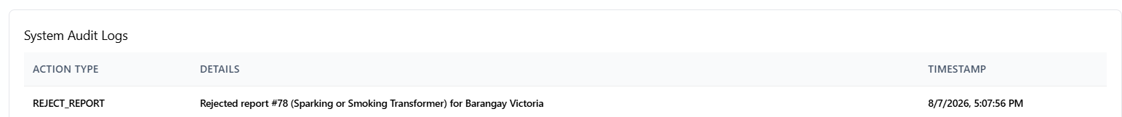
Database
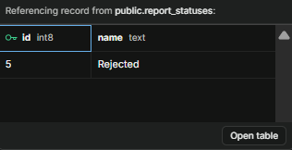

ACTIVITY 5
INTERNAL FUNCTIONALITY VERIFICATION

Purpose
To verify that developed modules are functioning properly before integration.
Procedure
- Conduct peer testing.
- Verify inputs and outputs.
- Identify issues encountered.
- Record findings.
- Complete Form 5.

FORM 5
MODULE VERIFICATION CHECKLIST

Directions
Evaluate each completed module.
Module | Functioning Correctly | Needs Revision
User Authentication | □ | ☒
Lineman Module | □ | ☒
Resident Module | ☑ | □
Report Receiving schedule | ☑ | □
Notification System | ☑ | □
Admin Dashboard | □ | ☒

Issues Identified
Issue | Severity | Action Taken
Inaccurate estimated time in power advisories. | High | Fix the database time zone.
Lineman status not responsive. | High | Apply proper workflow to determine the lineman status.
Inaccurate time on report progress tracker. | Medium | Synchronized the report tracker timestamps with the correct system time zone.
There’s no descriptive analytics for resolved reports. | Low | Add analytics.

Team Verification
Test Conducted By: Allysa Reyes

Date: August 5, 2026

ACTIVITY 6
REPOSITORY UPDATE REPORT

Purpose
To document all development activities uploaded to the repository.
Procedure
- Commit all completed work.
- Update repository documentation.
- Record commits made.
- Complete Form 6.

FORM 6
REPOSITORY UPDATE REPORT

Repository URL: https://github.com/ISELCONNECT-ORG/iselconnect_mobile

Commits Made This Week
Commit Description | Date
Feat: no internet connection screen | August 5, 2026
Feat: users’ active status and lineman availability | August 5, 2026
style: removing of map on Resident's | August 4, 2026
fix: scheduled report | August 2, 2026

Repository URL: https://github.com/ISELCONNECT-ORG/iselconnect_web

Commits Made This Week
Commit Description | Date
Style.AdminDashboard | August 5, 2026
Feat.LinemanLocationTracking | July 30, 2026
FixReportVerificationByAdmin | July 30, 2026

Repository Evidence
MOBILE  □ Updated Source Code  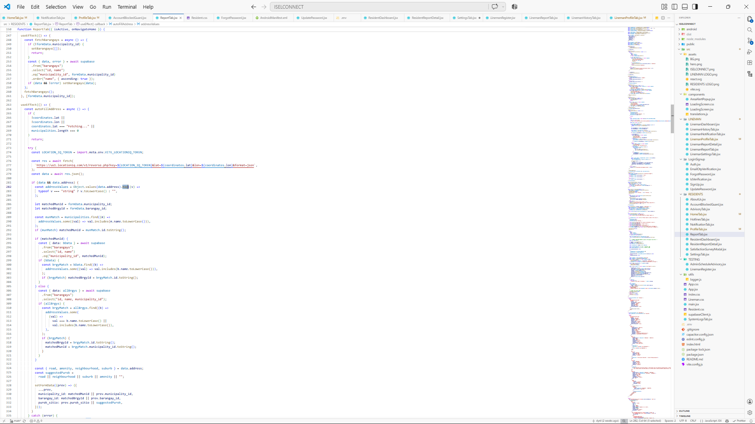 | □ Commit History Screenshot  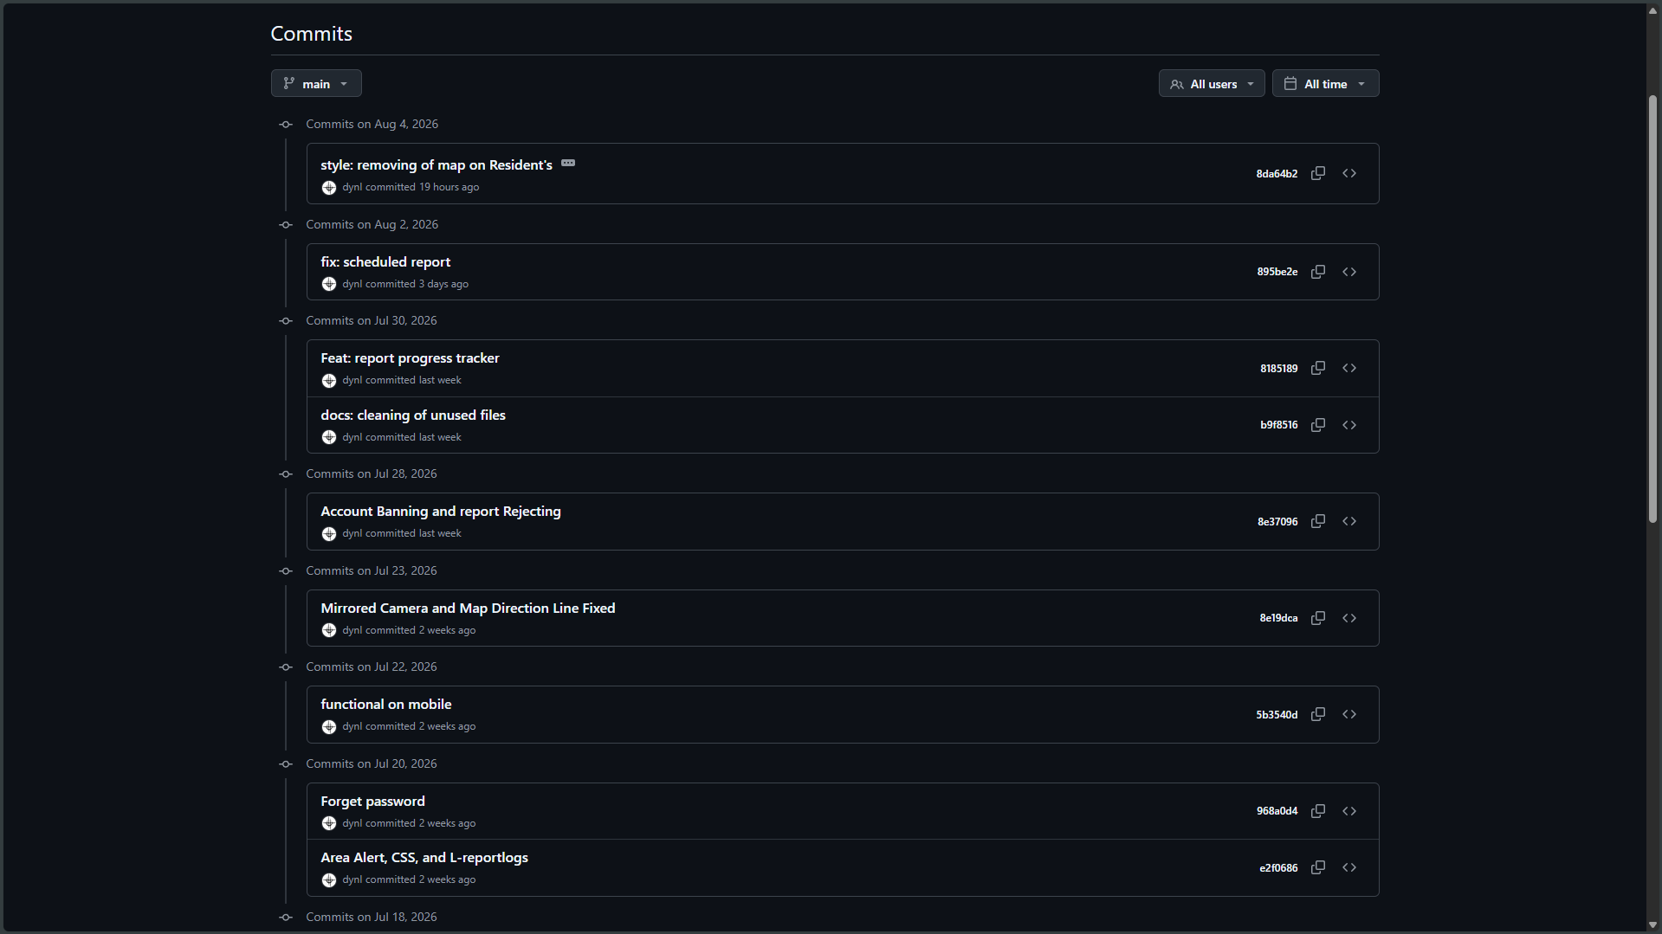
□ Team Contributions Screenshot  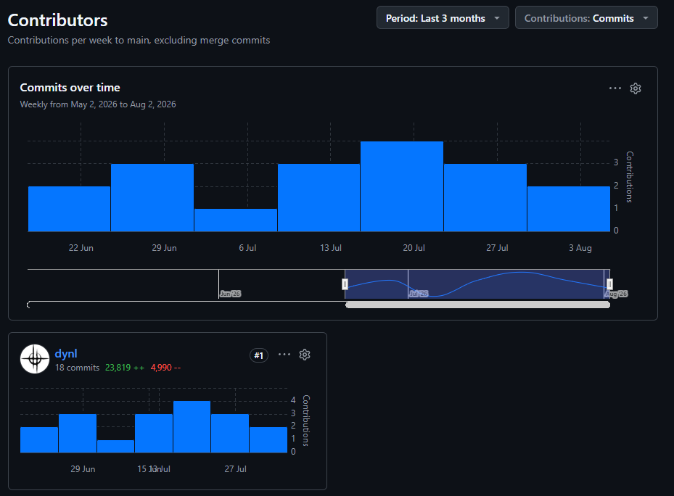 | 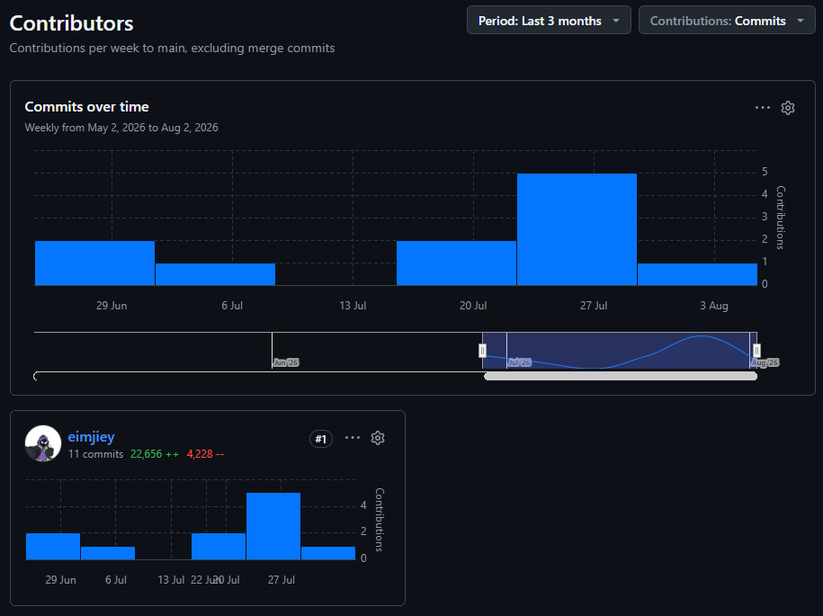
WEB
□ Updated Source Code
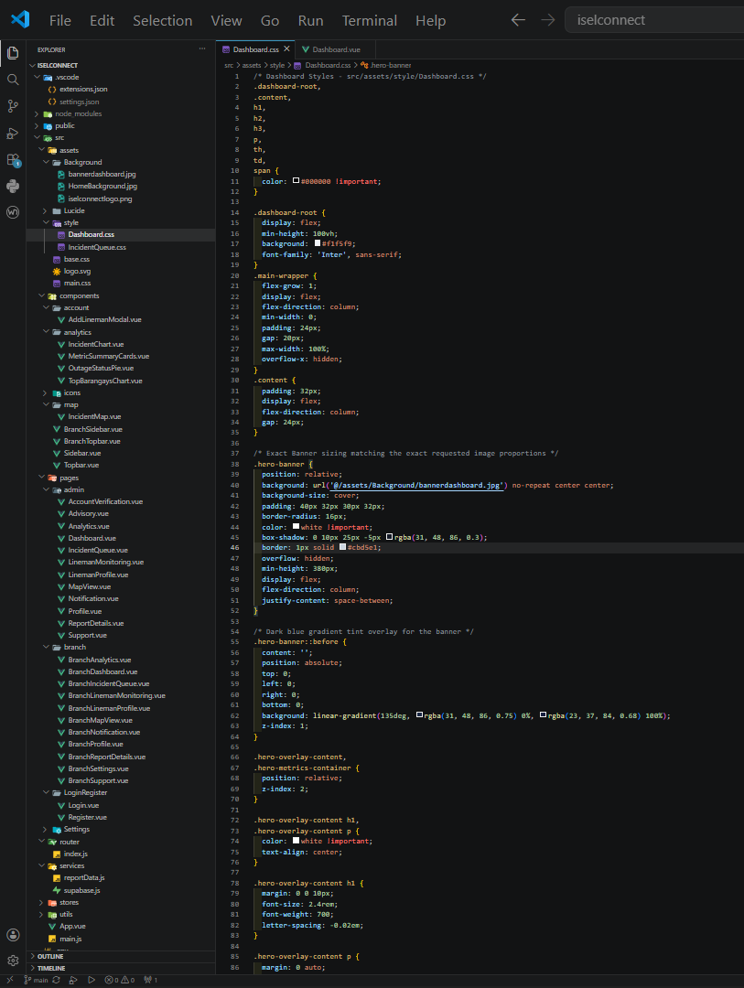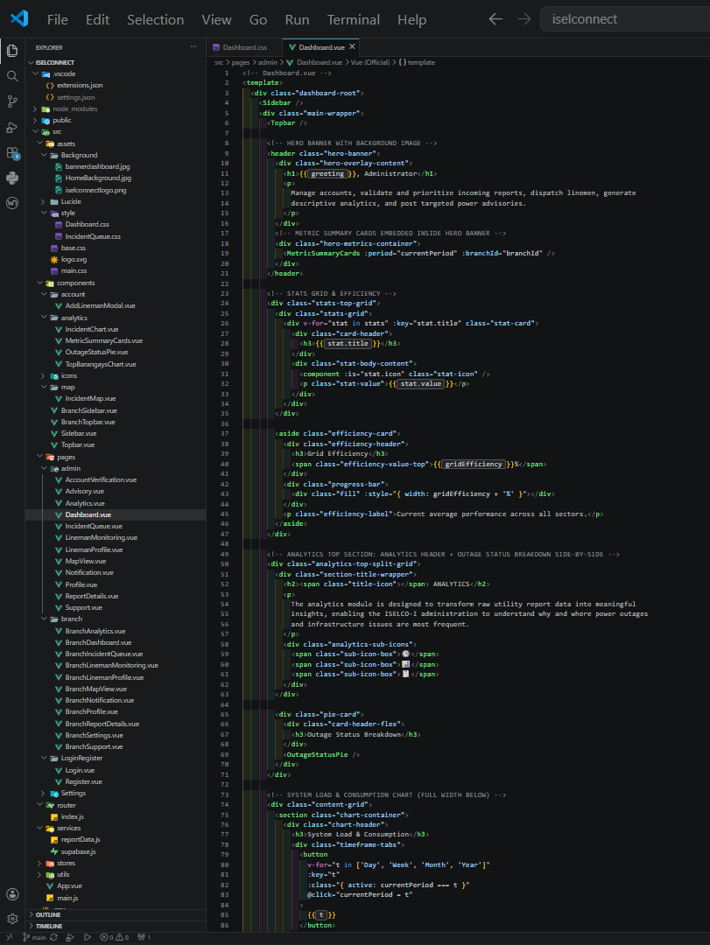

ACTIVITY 7
PROGRESS REPORT NO. 1

Purpose
To summarize development accomplishments during Week 3.
Procedure
- Review all completed activities.
- Summarize accomplishments.
- Identify challenges encountered.
- State plans for Week 4.
- Complete Form 7.

FORM 7
PROGRESS REPORT NO. 1
Project Information
Project Title: ISELCONNECT: A Power Outage and Visual Maintenance Report Management System

Date Submitted: August 7, 2026

Accomplishments This Week
Activity | Status
Core Functionality Development | In Progress
User Interface Development | In Progress
Workflow Configuration | In Progress

Major Accomplishments
- Completed the development of the core web and mobile application interfaces.
- Implemented the login, data entry, data processing, and report generation workflows.
- Integrated Supabase for database and backend services.
- Implemented report submission, status tracking, map-based location, and notification features.
- Conducted initial system testing and identified issues requiring refinement.

Challenges Encountered
- Inaccurate timestamps in power advisories and report progress tracking.
- Lineman availability/status was not updating consistently.
- Some report locations and map road paths were inaccurate.
- SMS OTP authentication was costly to implement and maintain.

Corrective Actions Taken
- Reviewed and corrected database timezone and timestamp handling.
- Improved the workflow for determining and updating lineman status.
- Refined GPS/location handling and map configuration.
- Reviewed the OTP authentication and notification process.
- Replaced SMS OTP with Email OTP to reduce costs while maintaining user verification.
- Performed repeated testing to verify the fixes and improve system reliability.

Planned Activities for Week 4
- Continue system development and feature integration.
- Complete pending modules and improve existing functionalities.
- Conduct further testing and fix identified issues.
- Refine the user interface and system workflow.

Prepared by: Allysa B. Reyes

Group Leader

Reviewed by: Dr. Desiray D. Nayga

Project Adviser

